**Ideation Phase**

**Define the Problem Statements**

|  |  |
| --- | --- |
| Date | 19 September 2022 |
| Team ID | PNT2022TMID23524 |
| Project Name | Smart Solution for Railways |
| Maximum Marks | 2 Marks |

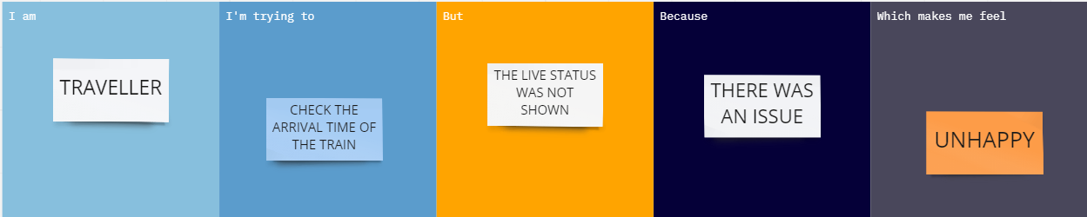

|  |  |  |  |  |  |
| --- | --- | --- | --- | --- | --- |
| **Problem Statement (PS)** | **I am (Customer)** | **I’m trying to** | **But** | **Because** | **Which makes me feel** |
| PS-1 | Traveller | Electronically validate my seat | There is no such option | There is no sensor located on my seat to validate my ticket | Disappointed |
| PS-2 | Traveller | Get compensation for cancelled trains | There is no immediate automatic compensation | The current procedure of requesting for compensation via post or email is not so fast. | Helpless |